**Quizophile**

*Dissertion Submitted in Partial fullfillment of the*

*Requirement for the Award of the Degree of*

*Bachelor of Computer Application*

*Semester IV*

*Jan – May, 2019*

Under the guidance of - Submitted By

Mr. Kl Suryawanshi Shubham Kumar Jha

1710163

Project Coordinator - Paras Kavadikar

Mr. Hitesh Nimama 1710141

Suyash Parashar

1710168

**School of Computer Science & IT**

**Devi Ahilya Vishwavidyalaya, Indore, M.P.**

**2019**

**School of Computer Science & IT**

**Devi Ahilya Vishwavidyalaya, Indore, M.P.**

**DECLARATION**

I hereby declare that the project titled “Quizophile” submitted by us for the partial fulfilment of the requirement for the award of Bachelor of computer application to School of Computer Science & IT, Devi Ahilya Vishwavidyalaya, Indore, comprises my own work and due acknowledgement has been made in text to all other material used.

Signature of Student:

Date:

Place:

**School of Computer Science & IT**

**Devi Ahilya Vishwavidyalaya, Indore, M.P.**

**CERTIFICATE FROM GUIDE**

It is to certify that dissertation on “Quizophile”, submitted by **Mr. Shubham Kumar Jha, Mr. Paras Kavadikar and Mr. Suyash Parashar** to the School of Computer Science & IT, DAVV, Indore has been completed under my supervision and the work is carried out and presented in a manner required for its acceptance in partial fulfilment for the award of the degree of Bachelor of computer application.

**Project Guide**

Signature:

**Name:**

**Date:**

**School of Computer Science & IT**

**Devi Ahilya Vishwavidyalaya, Indore, M.P.**

**CERTIFICATE**

This is to certify that we have examined the dissertation on Quizophile submitted by **Shubham Kumar Jha, Paras Kavadikar and Suyash Parashar** to the School of Computer Science & IT, DAVV, Indore and hereby accord our approval of it as a study carried out and presented in a manner required for its acceptance in partial fulfillment for the award of the degree of **Bachelor of Computer** **Application.**

**Examiner**

Signature:

Name :

Date :

**ACKNOWLEDGEMENT**

We acknowledge our sincere thanks to those who have contributed significantly to this project.

It is a pleasure to extend deep gratitude to our internal guide, Mr. **K L Suryawanshi** SCSIT (**DAVV**), for his valuable guidance and support and to continuously prompt us for the progress of the project. We thank his for his valuable suggestion towards our project, which helped in making this project more efficient and user friendly.

We thank and acknowledge each and everyone’s effort that helped us in some way or the other for small and significant things.

From: Shubham Kumar Jha

Paras Kavadikar

Suyash Parashar

**ABSTRACT**

Quizophile deals with the playing a quiz by a player. It generates question on the basis of their general knowledge. It maintained the score or points according to playing performance , the question will be provided for a separate player to make the player’s status.

The Quiz not handling the particular subjects responsible to make the attendance for all students. Only if the player respond to a question with given options ,points or coins will be calculated. The player scorecard will be generated on the basis of playing time.

**LIST OF TABLES**

**1. Design view of “player” table:**

|  |  |
| --- | --- |
| **Field name** | **Data type** |
| *sno | Number |
| name | Text |
| mobile | Number |
| age | Number |

* denotes the primary key

Table2 named as questions which contains question number, question, option and correct answer. Table contains 50 questions which are selected randomly . Answer is also going to be checked from the database.

**2. Design view of “questions” table:**

|  |  |
| --- | --- |
| **Field name** | **Data type** |
| *qno | Number |
| Question | Text |
| O1 | Text |
| O2 | Text |
| O3 | Text |

* denotes the primary key

**3. Design view of “Quiz” table:**

|  |  |
| --- | --- |
| **Field Name** | **Data Type** |
| *Rule no | Number |
| Rules | Rules |

* denotes the primary key

**4. Design view of “leaderboard” table:**

|  |  |
| --- | --- |
| **Field Name** | **Data Type** |
| *rank | Number |
| name | Text |
| score | Number |

* denotes the primary key

**EXECUTIVE SUMMARY**

**CHARACTERISTICS OF PROPOSED SYSTEM**

* **User Friendly:** The proposed system is user friendly because the retrieval and storing of data is fast and data is maintained efficiently. Moreover, the graphical user interface is provided in the proposed system, which provides user to deal with the system very easily.
* **Reports are easily generated:** Reports can be easily generated in the proposed system so user can generate the report as per the requirement or in the middle of the session. User can give the notice to the students so he/she become regular.
* **Very less paper work:** The proposed system requires very less paper work. All the data is fetched into the computer immediately and reports can be generated through computers. Moreover, work become very easy because there is no need to keep data on papers.
* **Computer operator control:** Computer operator control will be there so no chance of errors. Moreover, storing and retrieving of information is easy. So work can be done speedily and in time

**TABLE OF CONTENTS**

**Topics Pg. No.**

1. Introduction ---------------------------------------------------------------------------------1
2. Objective ------------------------------------------------------------------------------------2
3. System Analysis ---------------------------------------------------------------------------3
4. Project Planning ---------------------------------------------------------------------------4
5. System Design -----------------------------------------------------------------------------5

5a. ER- Diagram ----------------------------------------------------------------------6

5b Level-0 DFD ------------------------------------------------------------------------7

5c Level-1 DFD ------------------------------------------------------------------------8

1. System Development Methodology------------------------------------------------------9
2. System Implementation ------------------------------------------------------------------10
3. System Testing ------------------------------------------------------------------------------11
4. Output Forms & Reports ---------------------------------------------------------------12-28

10. Scope For Future Development ----------------------------------------------------------31

11. Conclusion ----------------------------------------------------------------------------------32

12. Reference -----------------------------------------------------------------------------------33

**CHAPTER 1**

**INTRODUCTION:**



This is Quiz Application developed in vb.net. The software can be used to conduct quiz in any school or college. The software easily manages to store all the student details before entering into this software. Even the answers will be stored in the database. As soon as the student selects the answer, their answer will be compared to the answer in the database. If the answer matches, there will be an increment in the score.

The advantage is the employee/admin need not calculate the result. The system will automatically calculate the result of the student and each student’s result will be displayed in the descending order. Students can see their results in the leaderboard. As soon as the student registers, his/her details will be displayed in the database. So any details of any student can be viewed.This software is error free. Anyone can use this software. So use this software and get more benefits from this.

**CHAPTER 2**

**OBJECTIVE:**

We have developed and implemented software for Quiz programs. This software of ours can be used in schools, colleges, clubs and other institutions which conduct Quiz programs. Our Software starts with the registration of contestants with their name mobile no. and age to get registered. Our software also enables multi user registration. Our Software has a capacity of storing fifty questions with three options for each single question and a correct answer for it. We set the code in which all question come at random and if the answer is right, the program will check it from database and increase the marks.

First the questions are displayed then options will be displayed and we also have set a timer. This timer is set for 10 seconds, once the time has been passed then our software does not allow for us to click on the other options by making them disabled. Participants can click only one options for a single question.

Our Software also has an option of audio and video questions. In audio section audios will be played and questions will be asked with multiple choices, each question carries particular marks and these marks can be set according to the rules and regulations of Quiz held by managements. Each time score will be displayed and it will be calculated as perfectly set by our software. Leaderboards display the scores of various users and their respective results, the users with higher results get displayed on Leaderboards along with their results.

**CHAPTER 3**

**SYSTEM ANALYSIS**

**Analysis** is the process of breaking a complex topic or substance into smaller parts in order to gain a better understanding of it.

A project analysis can be deployed before a project gets off the ground or after it lands back down. When needed, project analysis and appraisal happens even after significant points in a project’s lifespan, to make sure everything is on track or to troubleshoot some issue that springs up.

In systems engineering and software engineering, **analysis** encompasses those tasks that go into determining the needs or conditions to meet for a new or altered product or project, taking account of the possibly conflicting requirements of the various stakeholders, *analysing, documenting, validating and managing* software or system requirements.

**FEASIBILITY STUDY:**

**Economically Feasibility:**

The system being developed is economic with respect to School or College’s point of view. It is cost effective in the sense that has eliminated the paper work completely.

The result obtained contains minimum errors and are highly accurate as the data is required.

**Technical feasibility:**

The technical requirement for the system is economic and it does not use any other additional Hardware and software.

**Behavioral Feasibility:**

The system working is quite easy to use and learn due to its simple but attractive interface. User requires no special training for operating the system.

**CHAPTER 4**

**Project Planning**

**Project planning** is part of project management, which relates to the use of schedules such as Gantt charts to plan and subsequently report progress within the project environment.

Initially, the project scope is defined and the appropriate methods for completing the project are determined. Following this step, the durations for the various tasks necessary to complete the work are listed and grouped into a work breakdown structure. Project planning is often used to organize different areas of a project, including project plans, work loadsand the management of teams and individuals. The logical dependencies between tasks are defined using an activity network diagram that enables identification of the critical path. Project planning is inherently uncertain as it must be done before the project is actually started. Therefore the duration of the tasks is often estimated through a weighted average of optimistic, normal, and pessimistic cases. The critical chain method adds "buffers" in the planning to anticipate potential delays in project execution.Float or slack time in the schedule can be calculated using project management software. Then the necessary resources can be estimated and costs for each activity can be allocated to each resource, giving the total project cost. At this stage, the project schedule may be optimized to achieve the appropriate balance between resource usage and project duration to comply with the project objectives. Once established and agreed, the project schedule becomes what is known as the baseline schedule. Progress will be measured against the baseline schedule throughout the life of the project. Analyzing progress compared to the baseline schedule is known as earned value management.

The inputs of the project planning phase 2 include the project charter and the concept proposal. The outputs of the project planning phase include the project requirements, the project schedule, and the project management plan.Project planning can be done manually, but project management software is often used.

**CHAPTER 5**

**SYSTEM DESIGN**

System Design is the solution to the creation of a new system . This is the important aspect made up of several steps. The computer efficient and successful system should provide the following is succession :-

* From where should we start
* Where we have to go
* Where should we stop

If the project is to be successful we will need several these questions. The answer of these questions is schema manner and is known as system design.

A systematic manner will be followed so as to achieve beneficial result at the end. It involves starting with a vague idea and ultimately developing it up into a useful system. The design phase is transition from a user oriented to a document oriented to the programmers.

Software report can be broken into a series of steps starting with the basic ideas and ending with the finished project.

**E-R DIAGRAM**

The E-R Diagram constitutes a technique for representing the logical structure of a database in a pictorial manner. This analysis is then used to organise data as relation, normalising relation and finally obtaining a relation database.

* **ENTITIES: Entities** specify distinct real- world items in an application.
* **ATTRIBUTES / PROPERTIES:** These specify properties of entities and relationships.
* **RELATIONSHIPS:** These connect the entities and represents meaning full dependencies between them.

QUESTIONS

GAME

Has

Answe-red by

Belongs to

LEADERBOARD

Player

**DATA FLOW DIAGRAM**

**Level-0 DFD**

player

Player answer

question

Player info

Correct answer

**LEVEL-1 DFD**

Question display Question fetch Question

Student

Student Answer

Choose answer

answer

Feedback(correct/incorrect)

student answer

Correct answer

correct answer correct answer

Register

Information stores player info

**CHAPTER 6**

**SYSTEM DEVELOPMENT METHODOLOGY**

**WATERFALL MODEL**

The **waterfall model** is a relatively linear sequential design approach for certain areas of engineering design. In software development, it tends to be among the less iterative and flexible approaches, as progress flows in largely one direction ("downwards" like a waterfall) through the phases of conception, initiation, analysis, design, construction, testing, deployment and maintenance.

The waterfall development model originated in the manufacturing and construction industries; where the highly structured physical environments meant that design changes became prohibitively expensive much sooner in the development process. When first adopted for software development, there were no recognized alternatives for knowledge-based creative work.

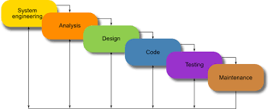

**CHAPTER 7**

**SYSTEM REQUIREMENT**

**HARDWARE:**

PROCESSOR Pentium-II or higher

PROCESSOR SPEED 533 MHZ

HARD DIDK SPACE 20 GB (min.)

RAM MEMORY 32 MB (64 MB recommended)

**SOFTWARE:**

OPERATING SYSTEM Windows 95/98/NT/2000

DATABASE SERVER MS Access

FRONT END VB.net

**CHAPTER 8**

**SYSTEM TESTING**

**System testing** is testing conducted on a complete integrated system to evaluate the system's compliance with its specified requirements.

System testing takes, as its input, all of the integrated components that have passed integration testing. The purpose of integration testing is to detect any inconsistencies between the units that are integrated together (called *assemblages*). System testing seeks to detect defects both within the "inter-assemblages" and also within the system as a whole.

System testing is performed on the entire system in the context of a Functional Requirement Specification(s) (FRS) and/or a System Requirement Specification (SRS). System testing tests not only the design, but also the behaviour and even the believed expectations of the customer. It is also intended to test up to and beyond the bounds defined in the software/hardware requirements specification(s).

* Unit Testing
* Integrated Testing
* Functional Testing
* Acceptance Testing
* Inserting of other value then what its format has.
* Inserting more records then the file can have.
* Loading of same page again and again to check that the all images are getting loaded all the time or not.

**CHAPTER 9**

**OUTPUT FORMS & REPORTS:**

1. Form1(loading page)

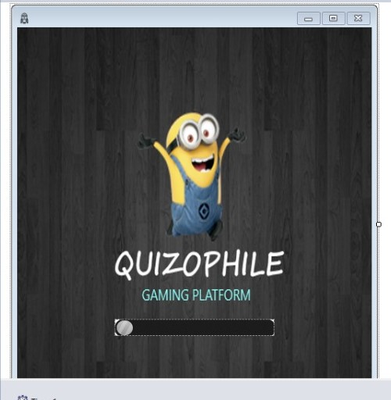

This form is just display the name of the game for 3000 milli second and the form2 will be open automatically.

2. Form 2(frontpage)

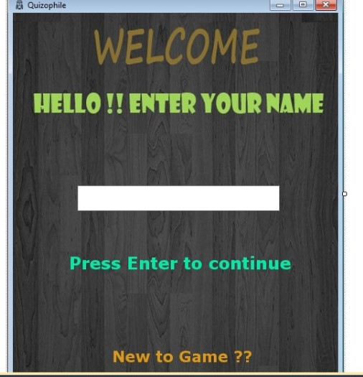

Form2 is the Front page of the project ’quizophile’. Here you have to enter your name and press enter if you already register in the game .But if you are new to the game you will have to register first by clicking on “New to Game ??” and only then you can continue,

3. Form3(Registration page)

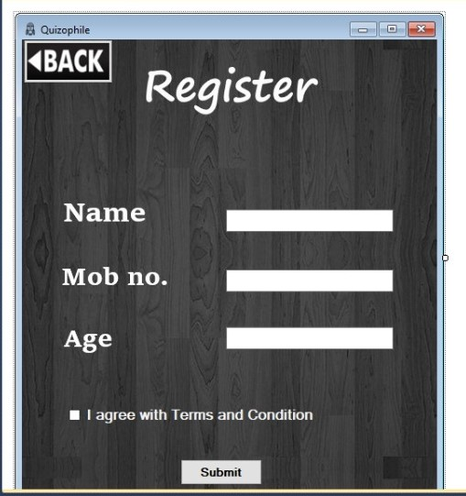

Form3 is the page where the player has to register himself before playing. Player has to feed in the simple details like their name, mobile number, age and then click to submit button after agreeing to terms and conditions.

4. Form4(Start page)

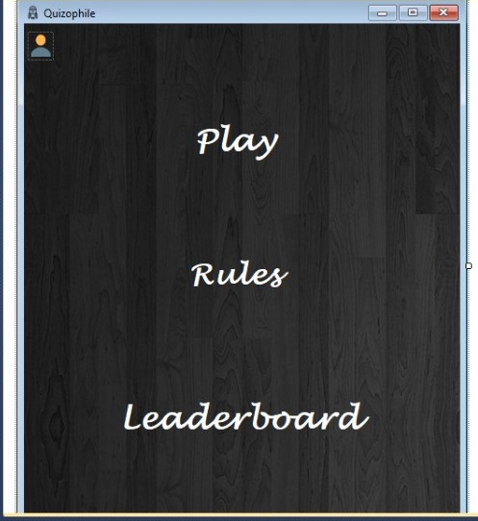

In Form4 player gets the options to start the game or player can see the rules by clicking on rules button and he can also see the leaderboards where names and score of the top 5 are displayed players according to their scores.

5. Form5(Rules page)

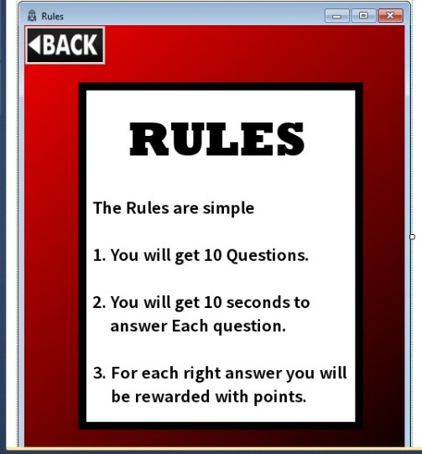

Form5 is the page where the rules are going to be displayed.

6. Form6(Leaderboard page)

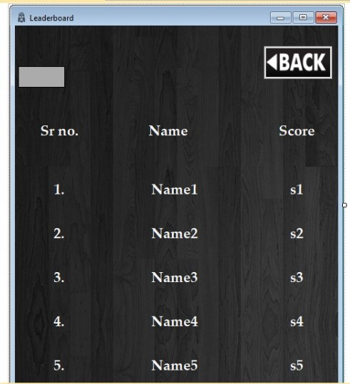

In this form players can see names and scores of the top 5 players who have ever played this game.

7. Form7(Question page)

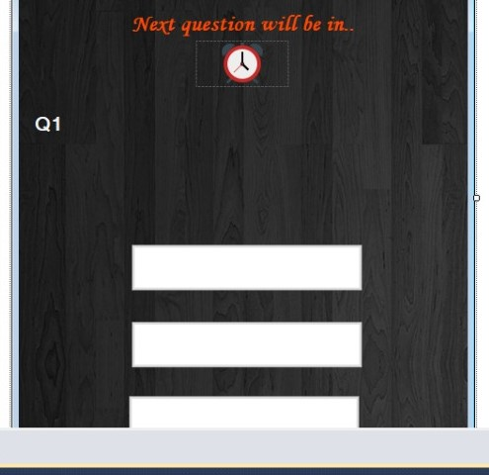

In this form questions are going to be displayed at random with three options. 10 questions will be displayed one after the other with a time span of 10 seconds for the right answer to be selected. For each right answer, you will be rewarded with points which will be shown on top right side of the screen.

8. Form8(Final page)

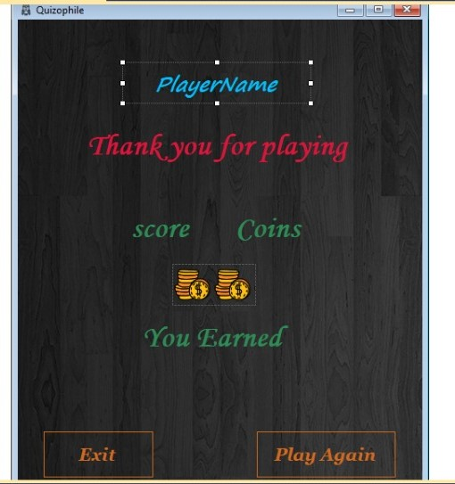

Here the scores of the players will be displayed after answering every question.

**Description:**

‘Quizophize’ is a quiz game which is made on vb.net on visual studio 2010. Eight different forms are used to perform different tasks.

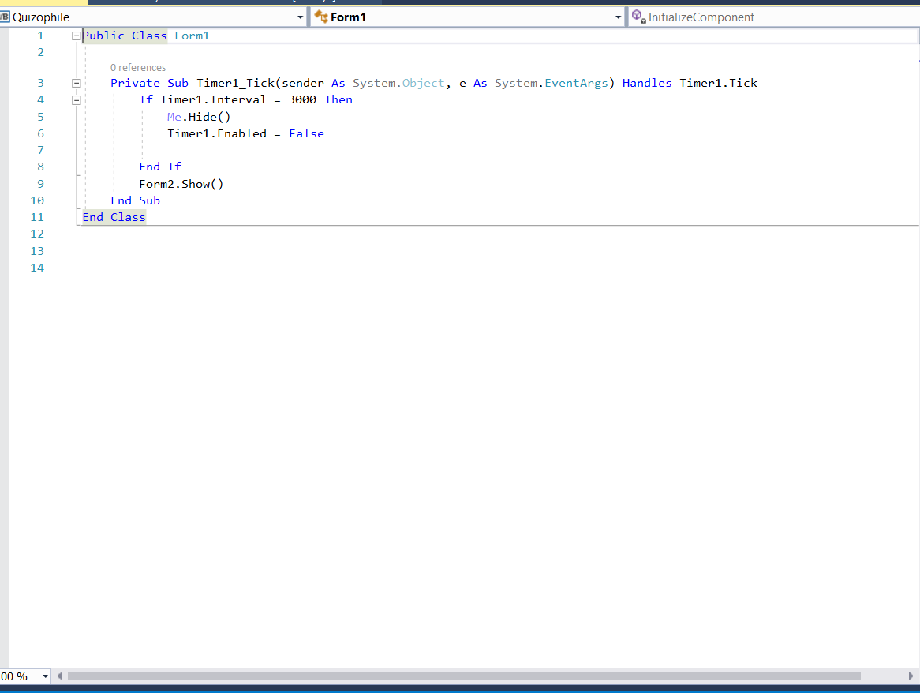

Form1 has a timer is which is used to display the form for 3000 milliseconds and then form2 is going to be open.

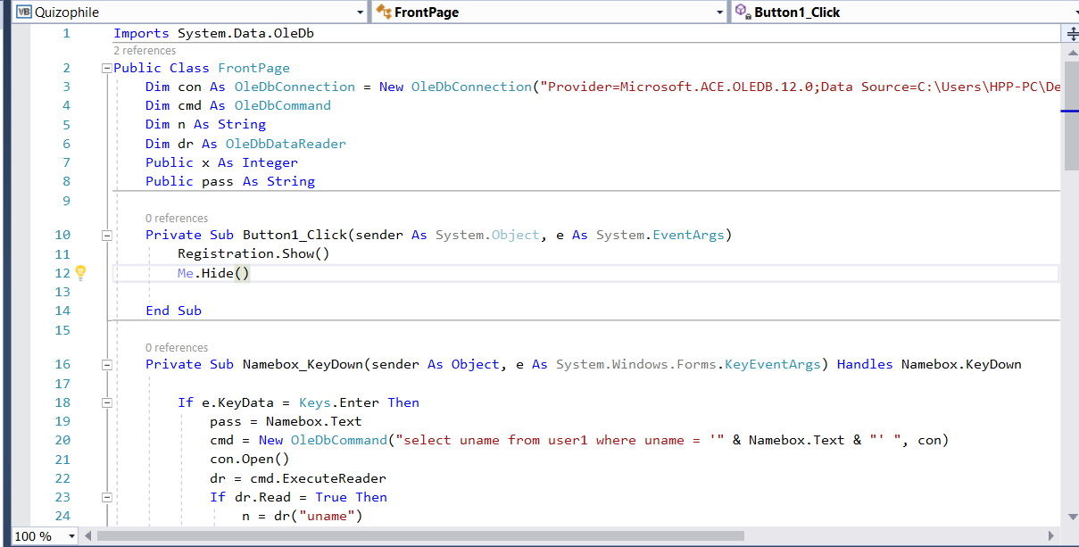

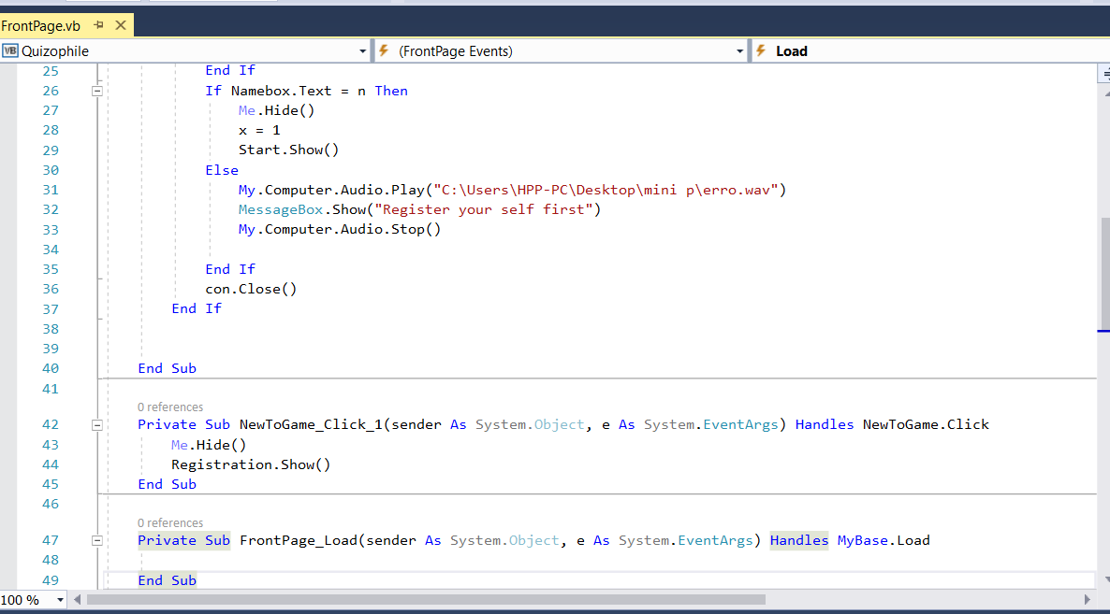

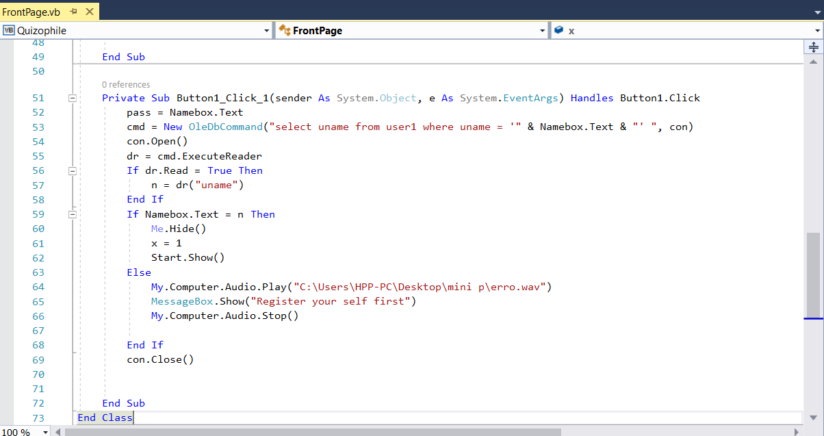

Form2 is the front page of the project ‘Quizophile’ which contains a textbox for the players to enter their name. All the information of registered player is in the access database if the player is not registered then a message will pop up “Register yourself”.

To register themselves, users have to click on “New to game” button which opens form 3.

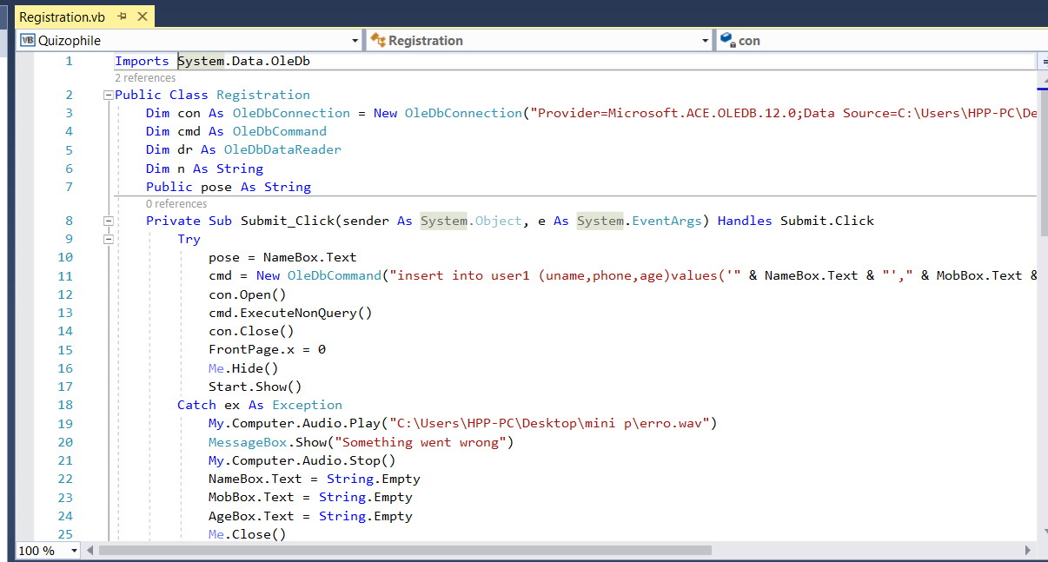

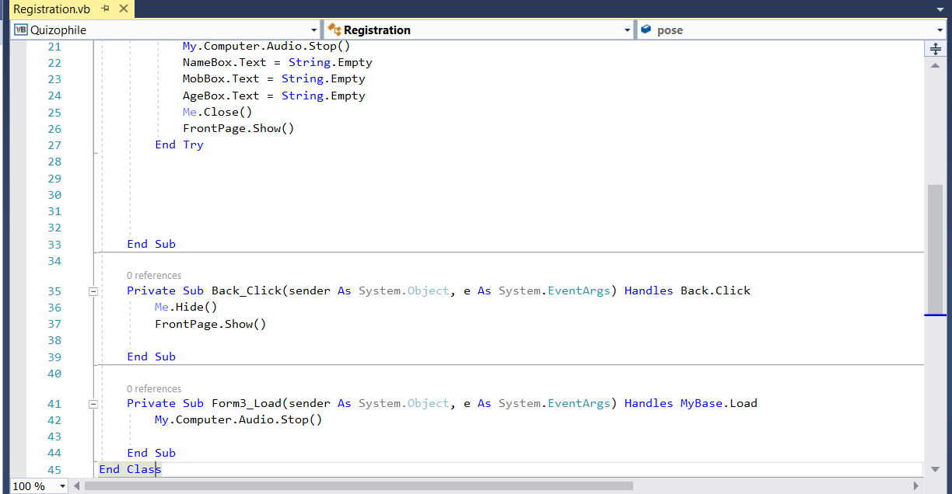

Registration of a new player is carried out in form3. There are three textboxes which are namebox, Mobbox and Agebox and three labels for taking basic information of the players like their mobile numbers, names and ages and all the information will be stored in the access database. And if their name is already stored in the database or if the user enters wrong format of mobile number or

age a message box is displayed on the screen and the frontpage of the game is opened.

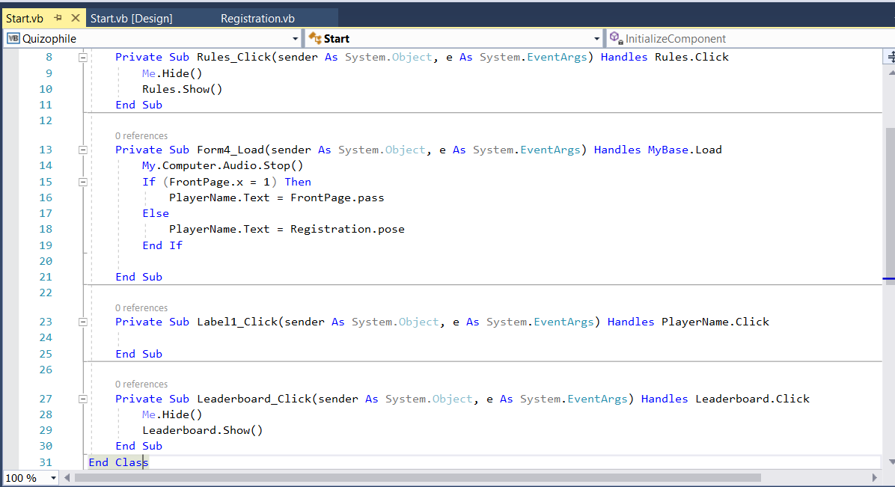

Form4 contains three button ‘play’,’ rules’ and ’ leaderboard’ which open different forms according to their names and player’s name is going to be displayed on the top left corner of the form in label called ‘playername’.

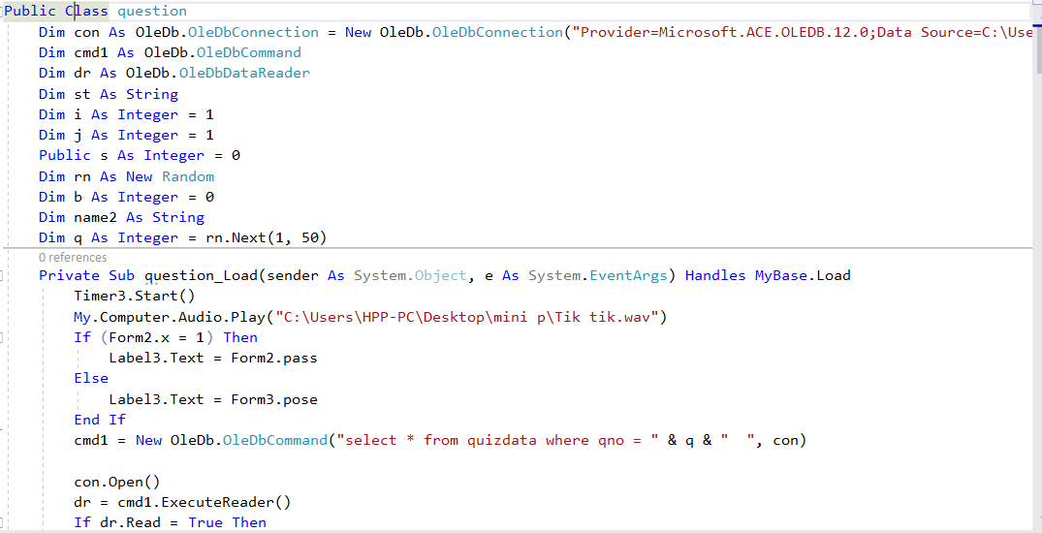

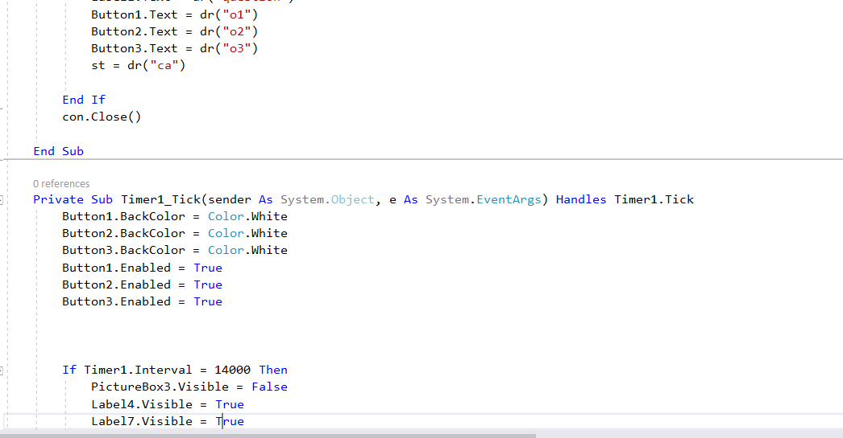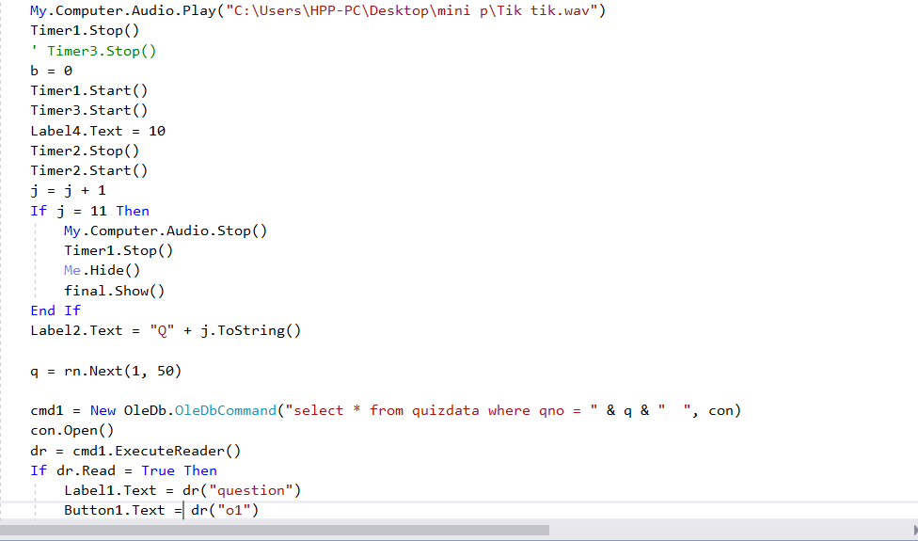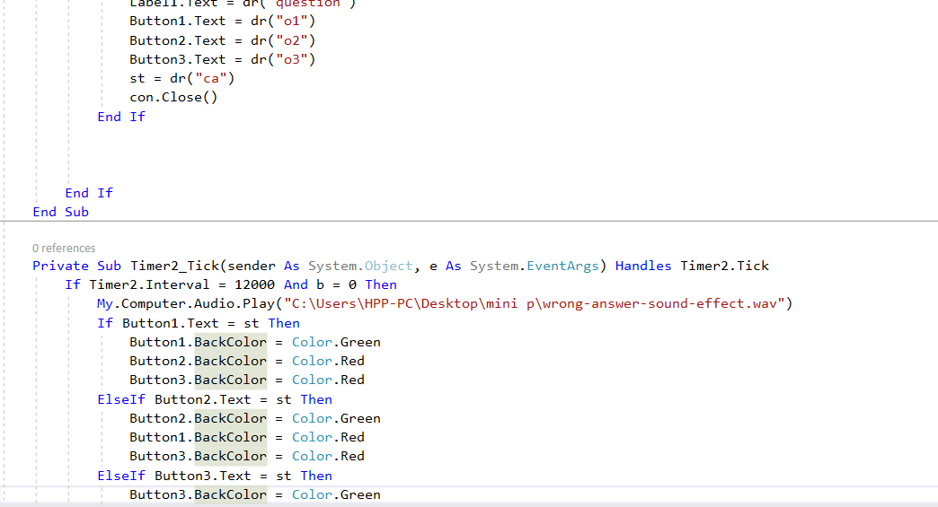

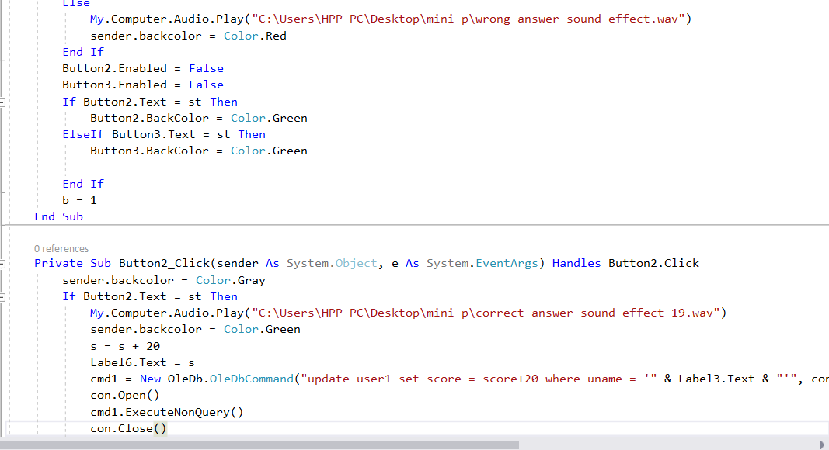

This form will display questions on a label, where questions are selected and retrieved from database by a random function and their respective options will be displayed on the buttons. Correct answers are also stored in the access database. If the players select right answer then the colour of the button will turn into green and if he chooses wrong answer, then the button will turn into red colour. If a player does not select any answer then all the buttons will turn red. 20 points are going to be added in the score of the player for each right answer and player can see his name and coins on left and right corner respectively on the top of the form. Each question will be changed in 12 seconds and the player will get 10 seconds to select the right answer. After answering all ten questions final score is going to be displayed.

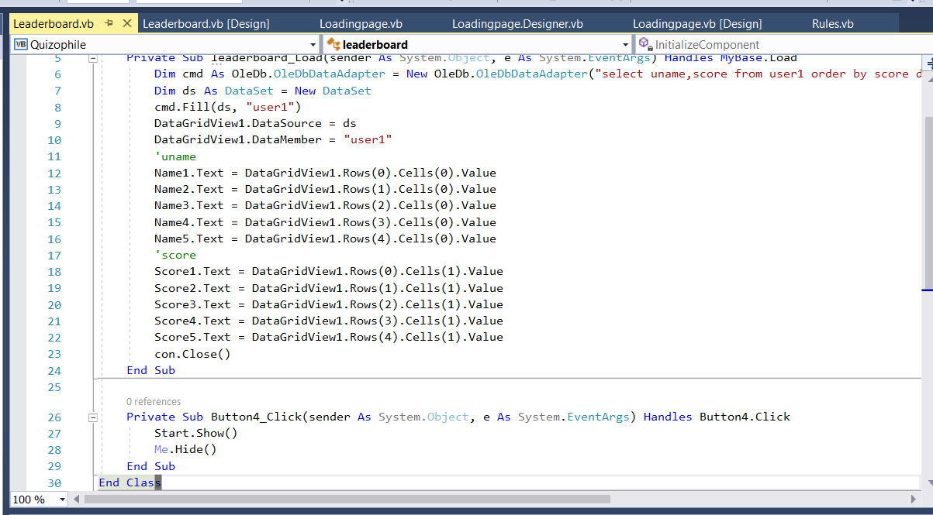

This form will show the leaderboard according to the scores stored in the database. Name and score both are going to be displayed in the labels by using datagird view. Only the score and name are selected from the datagird view which is in sorted form of decreasing order according to the score.

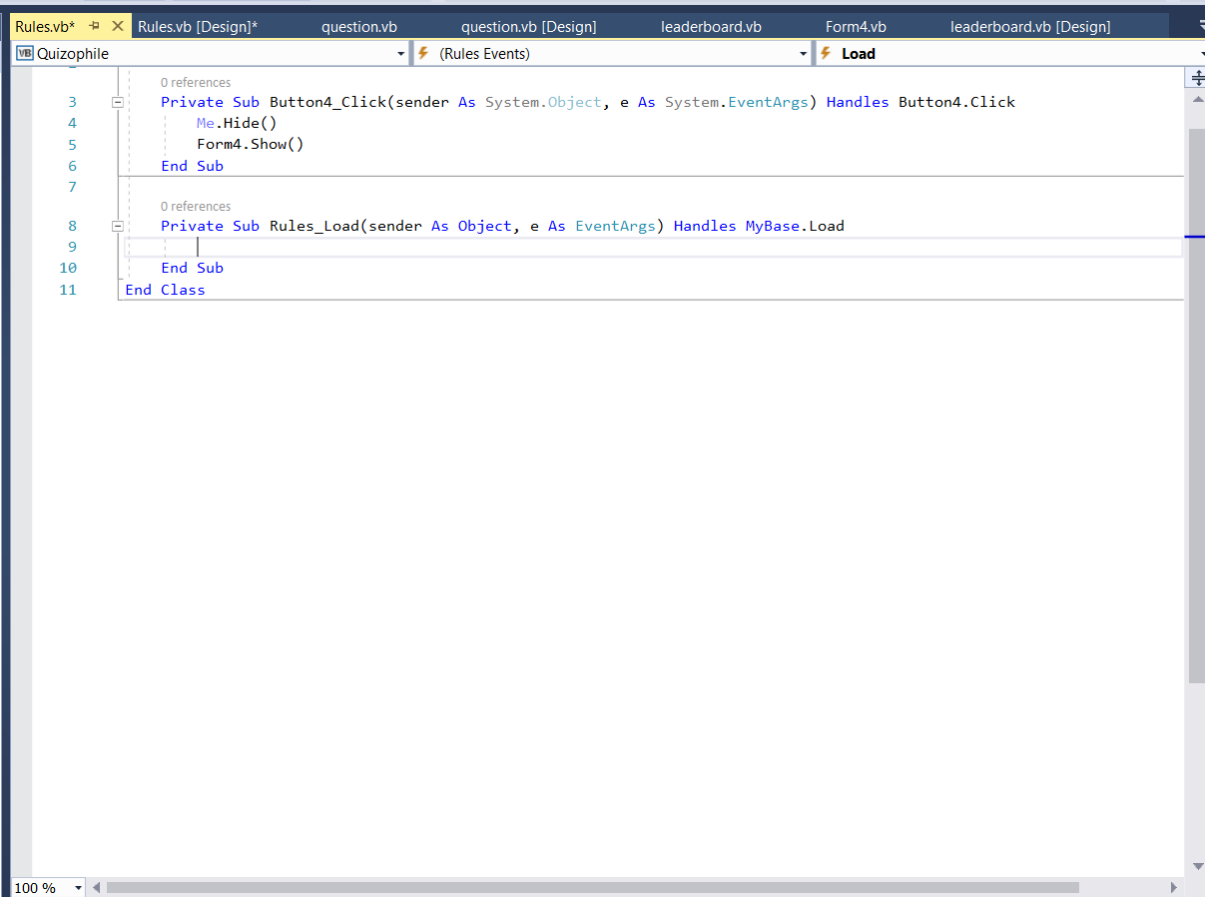

This form will simply show the rules and has a button which will take us back to the form4.

**Database used in ‘QUIZOPHILE’**:

MS Access is used as the Database Management System for the game there are two tables in the database. First table is named as user1 which contains the information of the players who register themselves in the game their information is saved in the database in the table user1. The table also contains the scores of the players which are retrieved for the leaderboard.

**SCOPE FOR FUTURE DEVELOPMENT**

The project has a very vast scope in future. The project can be implemented on internet in future. Project can be updated in near future and as when requirement for the same arises, as it is very flexible in terms of expansion.

With the proposed software of database space manager ready and fully functional the client is now able to manage and hence run the entire work in a much better, accurate and error free manner.

The following are the future scope for the project:

* It can be converted into a web based application.
* Answer will not display only result will be displayed at last.
* Can be used at fest’s in college for quiz contest.
* To increase the efficiency and security of the application, biometric verification could be taken

**CONCLUSION**

While making of the project on “Quiz game (Quizophile)” we made our progress by solving a number of problems. Finding the solution to each problem by ourselves was the most important part of the project and this provided us with experiences which will help us in future.

We came to know that how we can use ‘static’ keyword to store common data in two different forms. We learned how to use queries to retrieve, update and delete the data from a database. We also learned how to use tools like Timer, labels, buttons and textboxes etc. Database connectivity and usage of functions like data reader, data adapter and dataset was also a major part of our project.

Some important things that we learned include designing a good program architecture and converting real life situations into an efficient code, and how to write a good looking, easily readable and understandable as well as time and memory efficient code.

**REFERENCES**

**Books References**

1. Introducing Microsoft .NET, Second Edition author David S. Platt.

2. Joe Mayo, “**Microsoft Visual Studio 2012: A Beginner's Guide”**, Tata McGraw Hill, 2010.

3. Alex Mackey, **“Introducing .NET 4.5: With Visual Studio 2012”**, Press, USA, 2010.

4.Fundamentals of Database Systems, Sixth edition author Shamkant B. Navathe.

**WEBSITES**

1. http://www.msdn.net/

2. http://msdn.microsoft.com/en-us/library/orm-9780596518455-02.aspx

3. http://www.w3schools.com/asp.net/

4. http://www.cramerz.com/aspdotnet

5. http://www.dotnetspider.net/

6. http://www.stackoverflow.com

7. http://www.codeproject.com